 | Maple  Curriculum Coverage:  Autumn A 2026 | 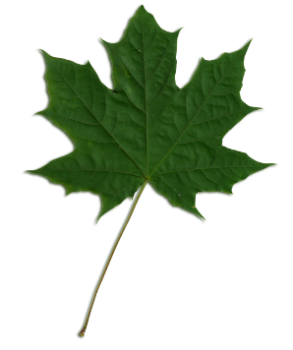

Welcome back after the Summer break! We hope you had a lovely holiday and are ready for a busy term ahead.

English:  This half term, Maple and Willow’s writing focuses will be persuasion and suspense.  They shall begin by creating holiday leaflets using persuasive techniques such as superlatives and expanded noun phrases, either based on their recent trip to the Isle of Wight or a holiday/tourist location of their choice.  The children will then move into their Talk for Writing unit about suspense. They will build on their knowledge of using ‘Show not Tell’, imagery and dialogue to create tension to write narratives that keep the reader guessing! | Maths:  In Maths, we will be looking at Place Value for the next couple of weeks, before moving on to four operations. They will learn about numbers to 10 million, multiply and divide numbers by 2 digits and solve multi-step reasoning problems involving more than one operation.  As part of increasing the children’s mathematical speed and fluency and embedding their prior knowledge, they shall take part in daily Maths NINJAs, Flashback4s and Fluent in Five.

History
Our History topic for this term is The Shang Dynasty. This topic will see the children learning about this early civilisation, the Shang people and the discoveries they made.

Geography
The geography focus is Deforestation and the impact this has on wildlife and the wider world.
PSHE
The PSHE focus for the half term is ‘Being Me in My World’. We use “Jigsaw” to teach PSHE.

Art/DT
The Art focus for this half term is “Expressing Ideas” through textiles and drawing. The artist the children are looking is Frida Kahlo.

French
The children will study a unit called “The Date” this half term in French, focusing on months, days and calendar events. They will also build on their vocabulary of food, greetings and nouns, gender and plurality obtained last year.

R.E.  Maple and Willow’s Religion and World Views topic for the half term is “What part did Wells Cathedral play in the transatlantic slave trade?”. | PE:  Maple and Willow’s Real PE unit for the half term is being delivered by Yeovil Football Club and will take place on a Thursday afternoon. This will focus on coaching and team development skills.  The children will also complete the Golden Mile this half term.

Science
Maple’s Science unit will be Evolution and Inheritance. This will be taught weekly and units will comprise of knowledge-based and working scientifically sessions.

All homework is set on Friday each week, to be completed by Friday. The children need to learn their spellings, access TT rockstars and complete their Year 5 & 6 workbooks. These will begin on Week 4 of this half term (WB 21.9.26).

